## Lessons 01 – 04: Grid Setup

Setting up a Grid is easy.

First:

* add GameObjects for the floor.
* add Colliders to each floor tile, which will be part of the Grid.

See a 3x3 tiles floor on here:

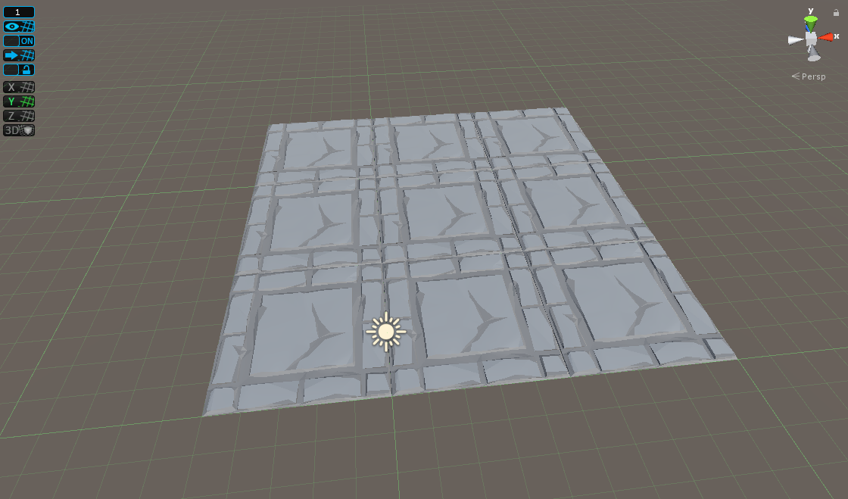

Next follow these steps:

* add an empty GameObject ‘Grid Manager’ to Scene
* add Script GameManager.cs to Grid Manager, add a Prefab for tile visualisation
* add empty GameObject ‘Grid Position’ as child to ‘Grid Manager’ GameObject
* add two empty GameObjects ‘Grid Min’ and ‘Grid Max’ as children to ‘Grid Position’
* add Script GridPosition.cs to GameObjects ‘Grid Min’ and ‘Grid Max’
* move GameObjects ‘Grid Min’ and ‘Grid Max’ to the positions where they mark the start of the Grid and its end. For better visibility in Scene an Icon may be added (optional)
* on all floor GameObjects which are to be part of the Grid add the Script GridPosition.cs.

Setup for Grid Manager:

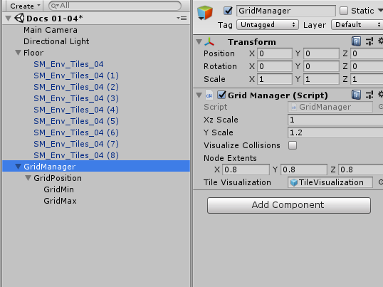

Setup for floor tiles:

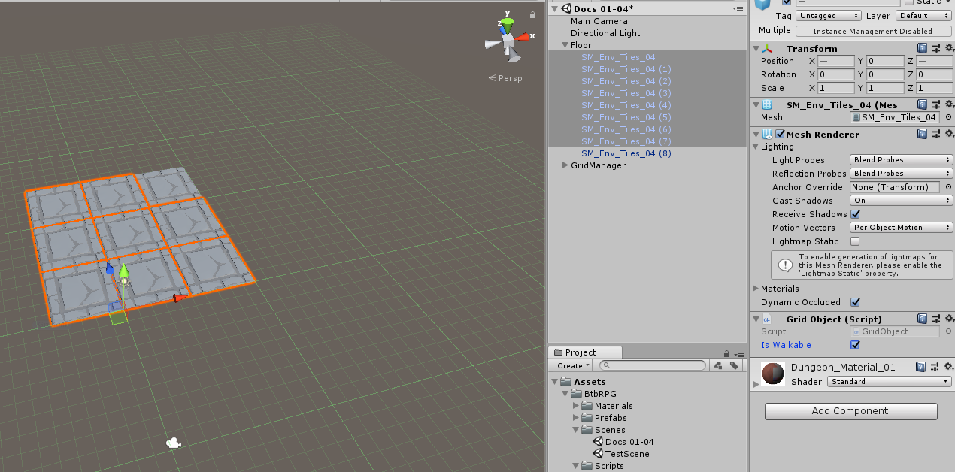

Next hit Play:

All floor tiles are now part of the Grid if between ‘Grid Min’ and ‘Grid Max’ and which do have a Collider and are GridObjects where ‘IsWalkable’ is true.

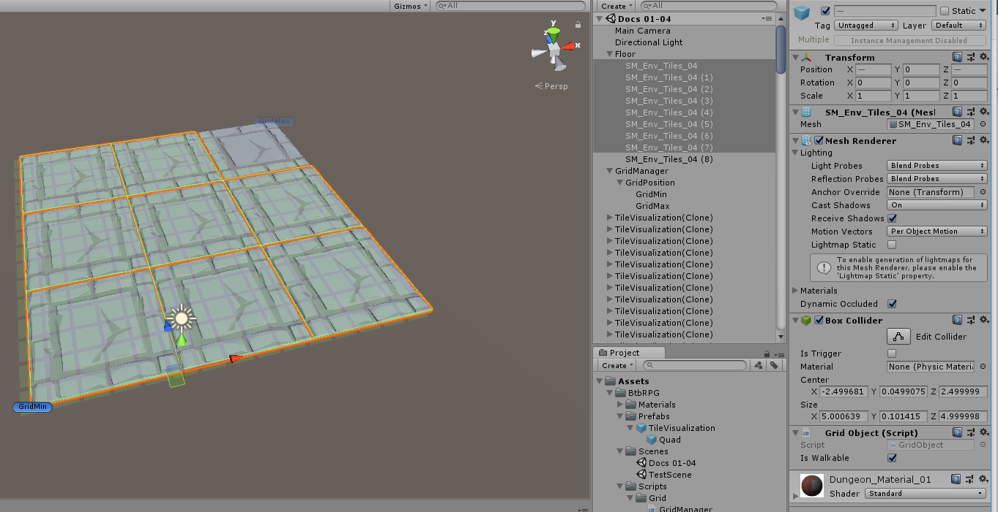

‘Grid Min’ and ‘Grid Max’ are basically Transforms, so multiple Grid levels are possible if the y-position of the Transform is used as well.

Finally: If GameObjects are added which do have are GridObjects but have ‘isWalkable’ set to false, those cells will not be on the Grid. Red boxes are Grid cells excluded.

